1. **Data Collection Jar**: This is where we gather all the information we need for teaching our computer. Imagine it like collecting all the ingredients before cooking.
2. **Feature Engineering Jar**: Here, we prepare our ingredients so our computer can understand them better. We might chop, slice, or mix them in different ways to make them easier for the computer to work with.
3. **Algorithm Selection Jar**: Just like choosing the right recipe for cooking, we pick the best method for our computer to learn from the ingredients we've prepared. Some recipes work better for certain types of food (or data) than others.
4. **Hyperparameter Tuning Jar**: Like adjusting the oven temperature or adding a bit more salt to taste, here we fine-tune our learning process to make sure our computer learns just the way we want it to.
5. **Evaluation Metrics Jar**: After cooking, we taste our dish to see if it's good. Similarly, we use different measures to see how well our computer has learned and if it can predict accurately.
6. **Deployment Jar**: Once our dish is perfect, we serve it to others. Similarly, we put our computer's learning to work in real-life situations, making sure it can handle new tasks just as well as it did in practice.

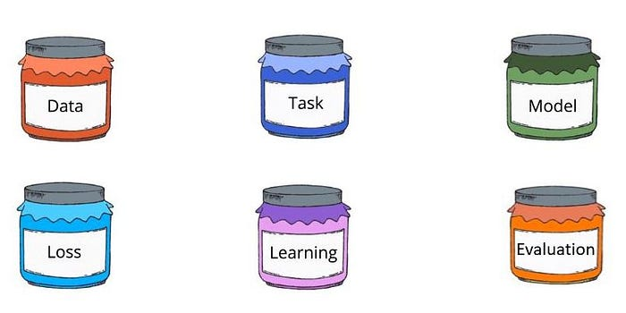

<https://scikit-learn.org/stable/modules/classes.html#module-sklearn.metrics>

<https://pypi.org/project/lazypredict/>